touch screen software

User Manual

catalogue
1 1 Software overview 5 5
1.1 Overview 5 5
1.2 Main functions 5 5
1.3 Software version 6 6
2 2 Software installation 6 6
2.1 Start installation 6 6
2.2 Open the query software design edition 7 7
3 3 Settings 7 7
3.1 Setting up the touch screen information 7 7
3.2 Disable startup 9 9
3.3 Background music 10 10
3.4 Global background video 10 10
3.5 Screen lists 11 11
3.5 Sending and receiving serial port messages 12 12
3.6 Sending UDP messages externally 14 14
3.7 Message reception transformations 16 16
3.8 Query software password 17 17
3.9 Query software design password 18 18
3.10 Button click sound effects 19 19
4 4 New pages 18 20
4.1 New pages 20 20
4.2 Setting the Page Background 22 22
4.3 Set the background video of the page 23 23
4.4 Page replication 24 24
4.5 Delete pages 24 24
4.6 Page attributes 24 24
5 5 Image 25 25
5.1 Editing images 26 26
5.2 Edit image properties 28 28
5.3 Edit animation 29 29
5.4 Links 30 30
5.5 Linking to external websites 31 31
5.6 Link to full-screen video 32 32
5.7 Linking to EXE Program 32 32
5.8 Mouse click effect 33 33
5.9 Replication 34 34
5.10 Delete 35 35
5.11 Staircase sequence 35 35
6 Text 36 36
6.1 Inserting text 35 36
6.2 Editing of texts 35 36
7 Article 378 37
7.1 Inserting articles 38 37
7.2 Editing articles 37 37
7.3 Editing properties 38 38
7.4 Article margins 39 39
8 8 Photo albums 42 42
8.1 Inserting an album 42 42
8.2 Editing photo albums 42 42
8.3 Editorial attributes 43 43
9 9 Mobile photo albums 45 45
9.1 Inserting a flowchart 45 45
9.2 Editing properties 45 45
10 layered photo album 46 46
10.1 Inserting a layered album 46 46
11 11 Video 46 46
11.1 Inserting a video 46 46
11.2 Edit video 47 47
11.3 Editorial attributes 47 47
12 Small window 49 49
12.1 Inserting a small window 49 49
12.2 Edit small window 49 49
12.3 Selected page width and height 51 50
13 Pop-up window 52 51
13.1 Inserting pop-ups 52 51
13.2 Width and height of pop-up pages 52 51
143D model 54 53
14.1 Inserting 3D models 54 53
14.2 Edit 3D model 55 54
15 GIF images 56 55
15.1 Inserting a GIF 56 55
16 Animation 57 56
16.1 Edit animation 57 56
17 Back button & Home button 59 58
17.1 Insert a return button 59 58
17.2 Back to 59 58
17.3 Insert a home page button 60 59
18 HDMI one host, multiple screen interaction 61 60
18.1 Setting up multi-screen communication modes 61 60
18.2 Screen lists 62 61
18.3 Adding screens 63 62
18.4 Connect two screens with an HDMI cable 63 62
18.5 Set your computer to extended mode 64 63
18.6 Designated link 66 65
18.7 Opening the software 66 65
19 UDP multi-host interaction 69 68
19.1 Setting up multi-screen communication modes 69 68
19.2 Screen lists 69 68
19.3 Designated link 68 72
19.3 Software installed on each screen 74 73
20 20 Flying screens 74 73
20.1 Selecting the fly screen 74 73
21 Lists and searches 75 74
21.1 Insert list templates 76 75
21.2 Editing list templates 77 76
21.3 A column of data 79 77
21.4 Abbreviations 79 78
21.5 Page name 79 78
21.6 Editing data sources 80 79
21.7 New pages 80 79
21.8 Modify page width and height 80 79
21.9 Filling the page content 81 80
21.10 Copying pages 82 81
21.11 Links 83 82
21.12 Project preview 83 82
21.13 Search text box 84 83
21.14 Search 84 83
21.15 Page buttons 85 84
Item 2293 85
22.1 Preview 86 85
22.2 Material centres 90 85
22.3 Migration to touch screen 87 86
23 23 Help 89 88
23.1 Software registration 89 88
24 Software Directive 90 89
24.1 Instructions that the software can receive 90 89

Software overview

1.1 Overview

The query software realizes the production and display of touch screen pages and touch interaction.
Supports dual screen interaction, flying screen, iPad video broadcast control, supports UDP messages and serial port messages.
The software is mainly used in exhibition halls, scenic spot guidance, floor guidance, museum exhibits, service hall guide, government party building, hospital lobby guidance, etc.

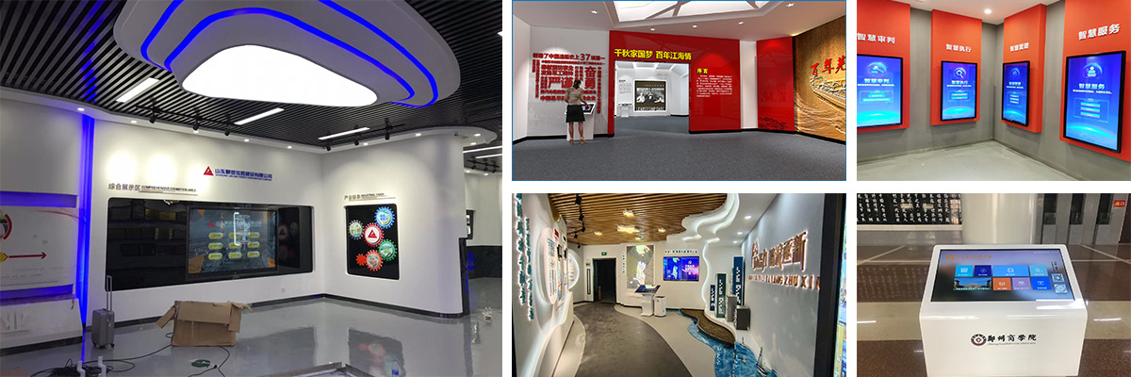

The software is divided into two parts:
(1) The query software design edition is used for touch screen page editing and layout
(2) The query software is used to display content, touch screen interaction and self-service inquiry to visitors.
Java runtime environment Java ：
Win10 and above memory 4G CPU Pentium and above

1.2 Main features

- Text, word, pdf can be added
- You can add pictures, videos, photo albums, GIFs, 3d models
- You can add links, web pages, small Windows, pop-ups, dates, animations
- HDMI one host, multiple screen interaction
- UDP multi-host interaction, using a tablet to control the large screen page switching
- Send serial port messages to control external devices such as lights
- Power on to automatically start, full screen display, full screen exit, automatically return to the home page
- You can set the background music and video
- Compatible with different screen resolutions
- Left page structure management
- Project migration, support multi-project management
- Page layout is self-service, easy to modify, easy to maintain

1.3 Software version

The software is divided into 64-bit and 32-bit versions. The 64-bit version is the default to maximize the performance of the device.

2 2 Software installation

2.1 Start installation
Double-click setup.exe Install. If the system does not have.net Framework 4.5.2 Visual C++2013 during the installation, it will automatically install it for you first, which may take two minutes. Double-click setup.exe Install. If the system does not have.net Framework 4.5.2 Visual C++2013 during the installation, it will automatically install it for you first, which may take two minutes.
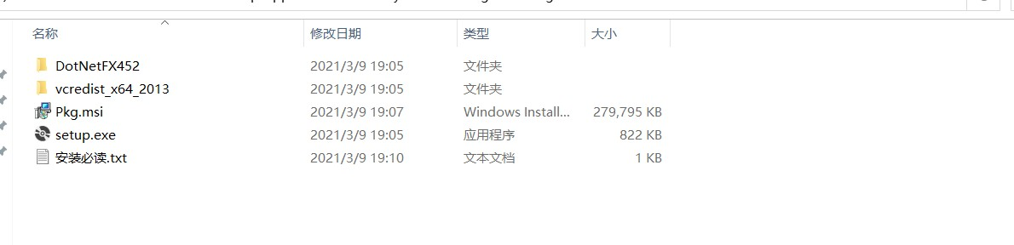

2.2 Open the query software design edition
(1) The menu
(2) Page structure is a navigation tree that is convenient to view the page when designing software
(3) The main interface is the content displayed in the query software
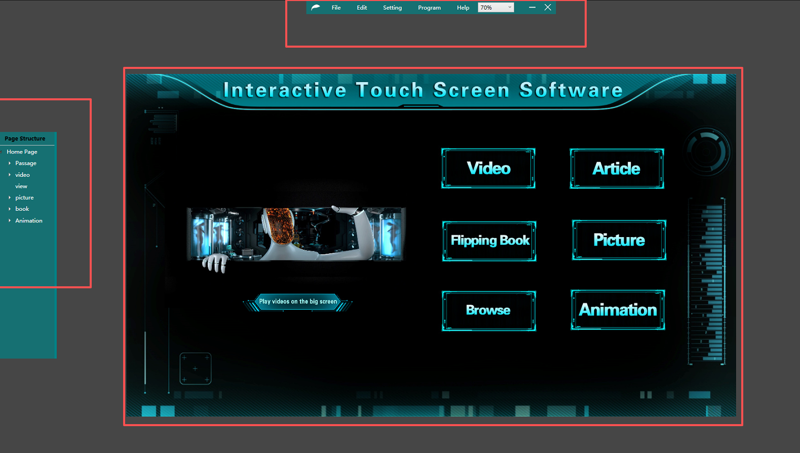

3 3. Establishment

3.1 Set up touch screen information
Settings – Touchscreen Information
Enter the width and height based on your touchscreen resolution. This must be filled correctly, as it determines the size of all pages you edit.
The image size of the PS design should also be equal to the resolution of the touch screen. Before operating this software, you must be able to use Photoshop or you have a designer.
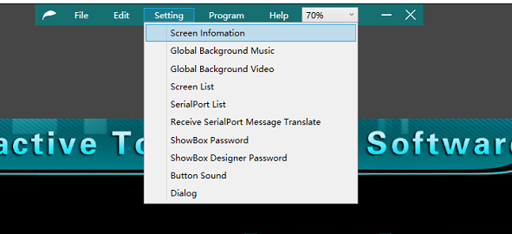
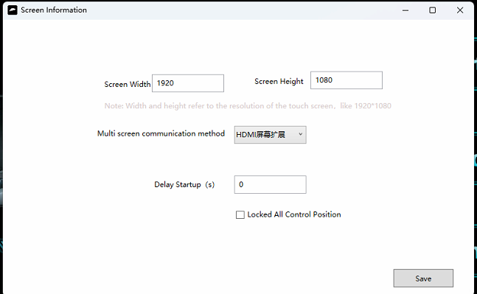
Screen width: Touch screen resolution width
Screen height: Touch screen resolution height
Multi-screen communication mode:
When you're a host, use an HDMI screen extension
When you are multiple computer hosts, use UDP communication
delayed start ：
How many seconds after the software starts up

3.2 Disable startup boot
Windows Task Manager-Start-ShowBox-Disabled
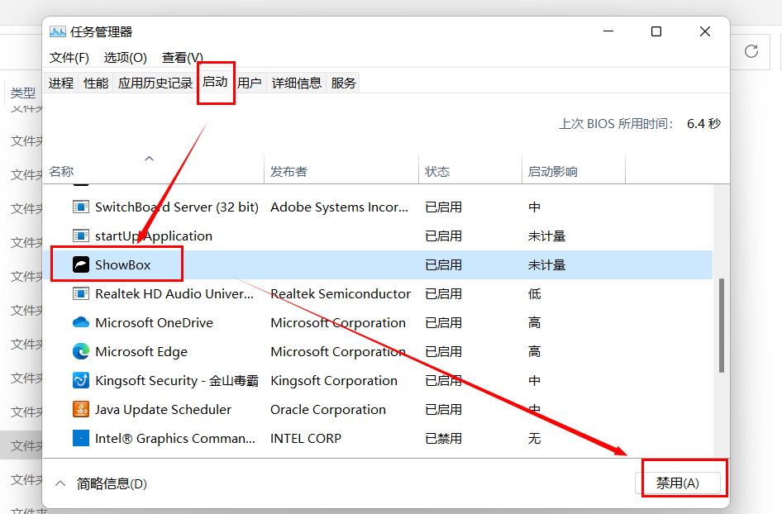

3.3 Background music throughout the game

Setting-Global Background Music You can set a global background music.
Then project-preview, see how it works

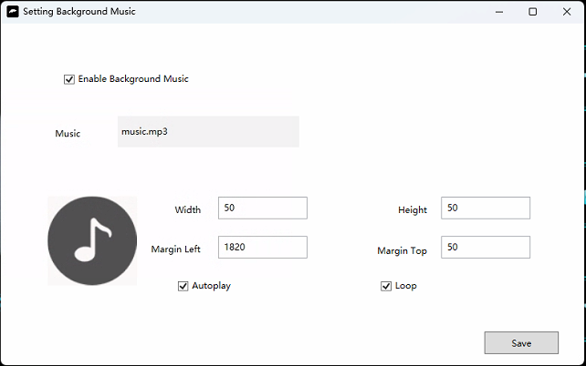

3.4 Global background video
This video is displayed at the bottom of all pages, which is equivalent to a dynamic page background
Setting-Global background video
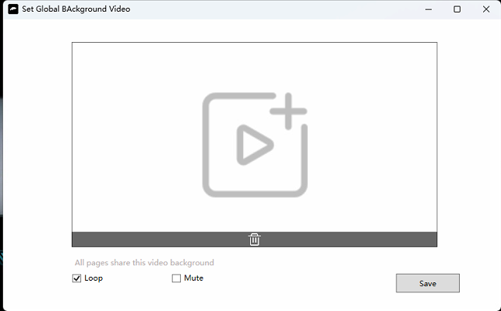

3.5 Screen List
Setting-Screen List
When you need to send a message from one screen to another, switch pages, and control video playback, you need to add multiple screens.
This section only describes the use of a single screen. For multi-screen reference, see later.

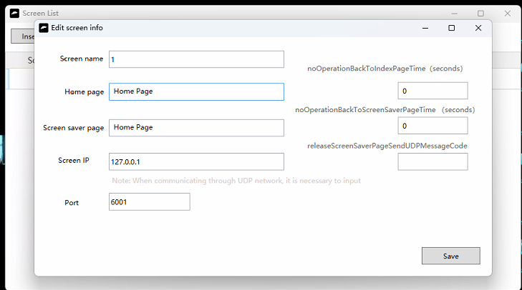
Screen name: Can be customized
Home page: The first page displayed when the software is opened
Unattended automatic return to home page (seconds): How many seconds it takes for the system to automatically return to home page
Screen saver page: The screen saver is displayed when the software enters the screen saver state
Unattended automatic screen saver (seconds): How many seconds without being operated, automatically enter the screen saver page
Screen IP address: Fill in 127.0.0.1 when there is only one host.
Port: The default is 6001.
The screen saver disappears and sends a UDP message: When the screen saver disappears, send a UDP message

3.5 Send and receive serial port messages
Setting-Sending and receiving serial port messages
1) Send serial port messages to external device relays to control the light switch
2) Receive serial port messages from the relay and can switch video
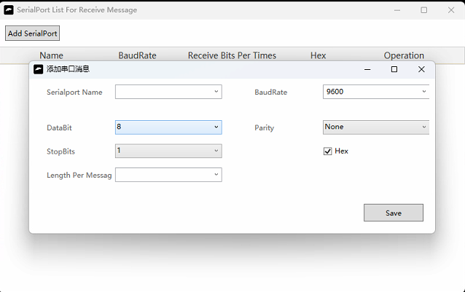
Enable sending and receiving serial port messages: After enabling, you can right-click the image-link-send message
Serial port name: When the relay is connected to the host through USB cable, the serial port name can be seen. Windows 7 computers need to install serial port driver, and Windows 10 has built-in driver
baud rate: the device is the standard, default 9600
Send hexadecimal message: After checking, the external message filled in by the user will be converted to hexadecimal and sent to the relay

3.7 Message reception transformation
Setting-Message reception conversion
Receive serial port messages from external devices and convert them into new messages for the current host
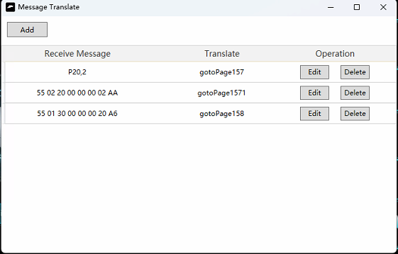

3.8 Query software password
Setting-Query software password
After the touch screen is turned on, the query software will be automatically started. At this time, you can only double-click in the upper left corner and enter the password to close the software.
Default password 666666
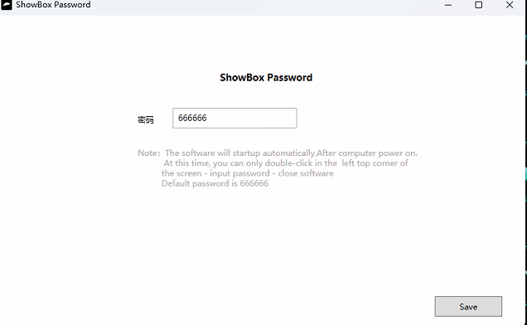

3.9 Query the software design password
Setting-Query software design password
After activation, users open the query software design edition and enter the password
The password is 6 digits. The default password is 666666
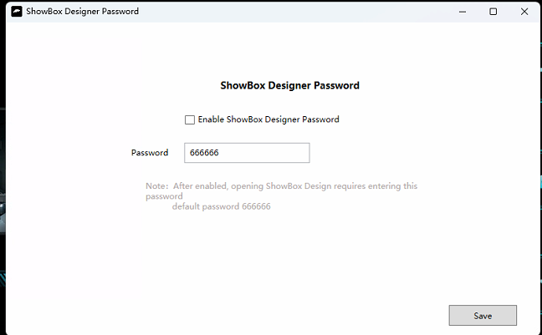

3.10 Button click sound effects
Settings-Click the sound button
There is a button sound when the user clicks on the image
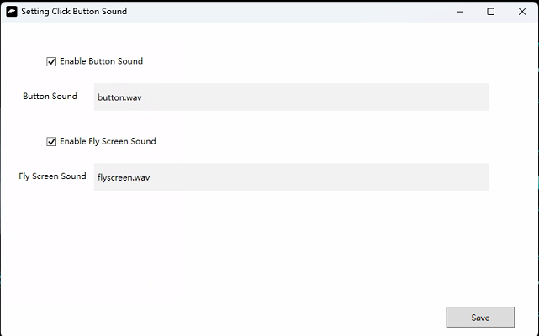

Enable button sound: Check this box and you will hear a sound when you click on the image
Button sound: Upload a WAV audio file

4 4. New pages

4.1 New pages

Click the home page-New Subpage, the new page is assigned to the home page below

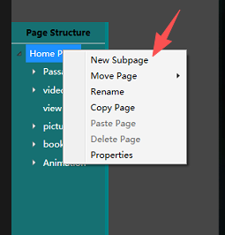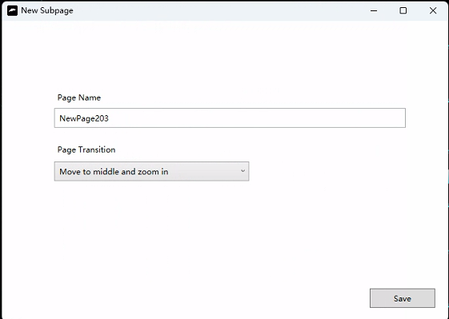

Page name: Please customize Page transition mode: refers to the animation effect of jumping from another page to the current page.

Fading, central diffusion, wave, left display, up display, roll up, refresh display cube, open, flying sheet The last three effects are 3D animations that occupy high device resources.

4.2 Set the page background

Right-click in the blank area – Set Page Background. Click Upload New Image – Save

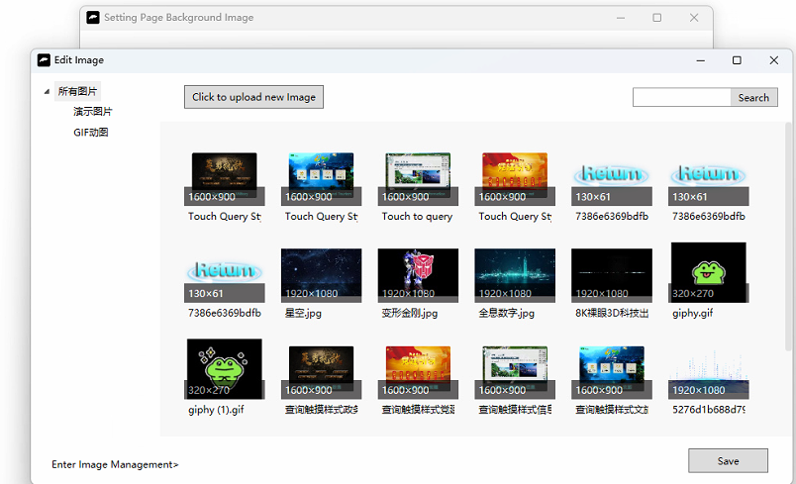

4.3 Set the background video of the page

Right-click in the blank area-Set the video background for the page To make it look cooler, you can create a silent background video
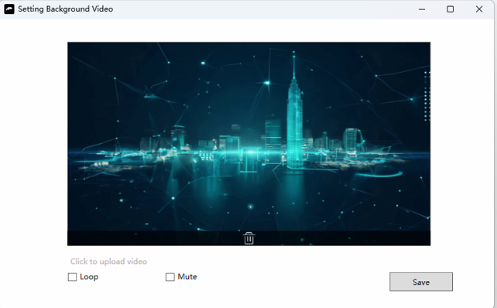

4.4 Page replication

Structure of the left page
(1) Right-click the page-Copy the page
(2) Right-click the page-Paste the page Use the copy page function to help you quickly create projects
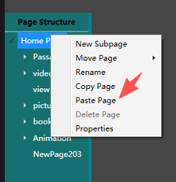

4.5 Delete pages
Right-click the page name-delete the page
Delete the current page

4.6 Page attributes
Right-click the page name-Properties
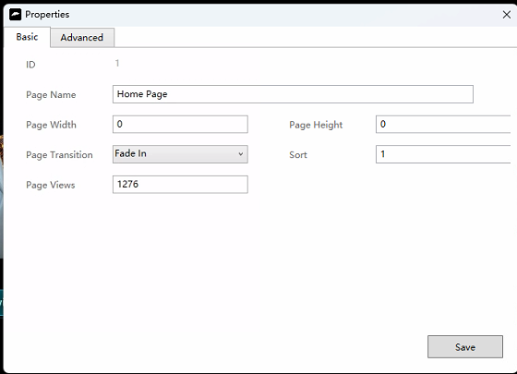
Number: Page ID
Page name: Can be filled in freely
Page width: If it is 0, it is the default width (set-touch screen information, the width filled here)
Page height: If it is 0, it is the default height (set-touch screen information, the height written here). When using the pop-up function, the page width and height can be changed to a smaller size, such as 1600 width and 900 height
Page switching mode: Click to enter the switching effect of the current page
Ordering: The order in which the page structure tree is planted

5 5 Images
Right-click in the blank space-Insert image

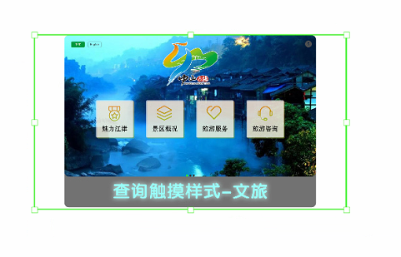
(1) Drag the image to move it
(2) The up, down, left and right keys of the keyboard can slightly move the position of the picture
(3) Hold down the dot at the bottom right to drag and stretch the image size

5.1 Editing images

Right-click image-Edit image
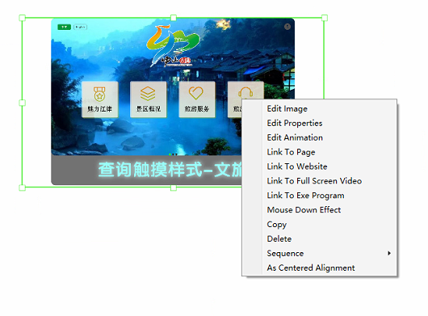

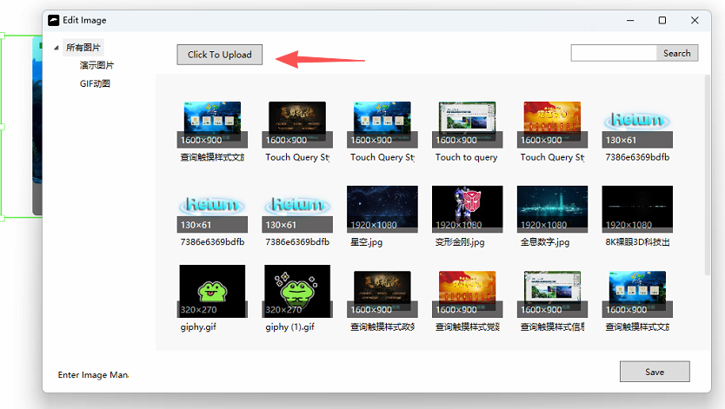
You can click to upload a new image or select an existing image from the list
Enter the image management: you can create a new folder, classify the management, delete the uploaded images

5.2 Edit image properties

Right-click image-Edit properties
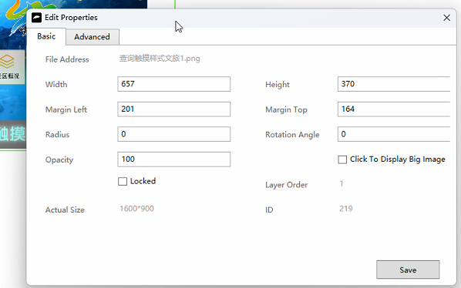
Image address: Click to enter the current image storage directory
Width: The current width of the image display
Height: The height currently displayed by the image

Left distance: How many pixels away the image is from the left
Top margin: How many pixels away the image is from the top
Transparency: The transparency of the image, 0-100 before, the smaller the more transparent
Rotation Angle: How many degrees clockwise the image is rotated
Click to view the large image: After checking, the user can click to display the large image, and can move, zoom, rotate, two-finger zoom the image
Round corners: The size of the rounded corners of the image
Original size: refers to the original pixel size of the image
Order of layers: the order in which multiple images are stacked
Button boundary: For example, each province on the map is a button. This is an irregular shape button. This should be combined with Blend for Visual Studio2013 to generate boundary strings. For details, please consult the technical staff.

5.3 Edit animation

Right-click image-Edit animation You can set animation effects to an image, which can be multiple animations.
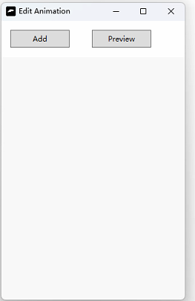
Add animation: Add a basic animation

Start time: How many seconds after the page opens to start the animation
Duration: How long the animation lasts
Number of times the animation is played: Set to 0 for loop
Uniform speed: whether the animation is played at a uniform speed
Constant transparency: Same transparency, by default the image is gradually becoming opaque
You can add multiple animations, preview the effects of the animations that are superimposed, and delete them

5.4 Links to

Right-click the image-link to
This image is used as a button and clicking on it will take you to the corresponding page
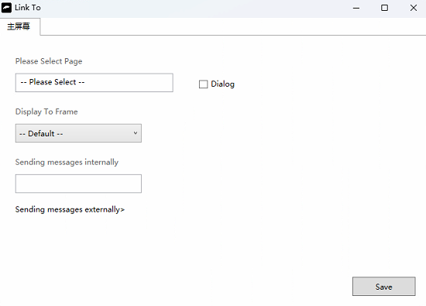
Select a page: Select the page to jump to
Pop-up: Whether to open the page in a pop-up form (if checked, it is better to set the width and height of the linked page to a small size, otherwise the pop-up will occupy the entire screen. Left page structure-right-click the page-properties-set width 1600 height 900)
Transparent pop-up: refers to the current pop-up with a transparent background by default (if no background image is set)
Display in this window: can be displayed in a small window specified
All window lists = main window + small window inserted by right click
Send messages internally: HDMI screen extension sends UDP messages to another screen; two hosts communicate via UDP, sending UDP messages to each other.
Send messages to external devices: Send serial port messages and UDP messages

5.5 Linking to external websites
Right-click image-link to external site
It's a link to a web address, for example http://cpjl.bffeng.com
Users click on the image and are redirected to this site. The software will use the built-in Google browser to open this site.
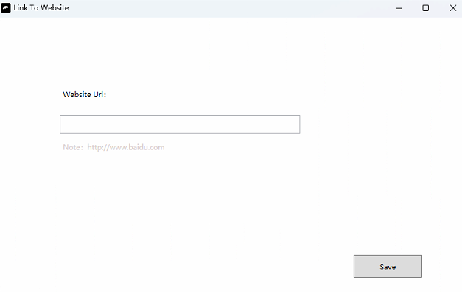

5.6 Link to full-screen video

Users can click on the image to play the video in full screen
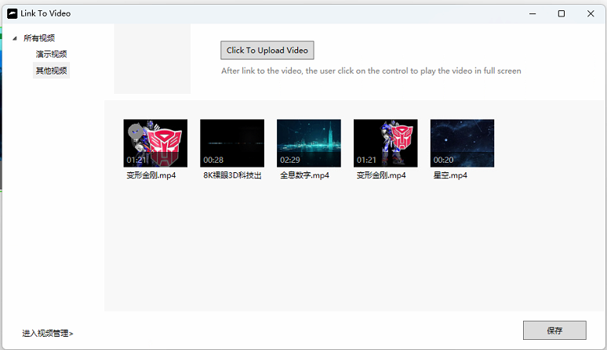

5.7 Link to EXE program

Right-click image-link to EXE program
Click the image to open an EXE application, if you choose a docx file, it will open word and display the file
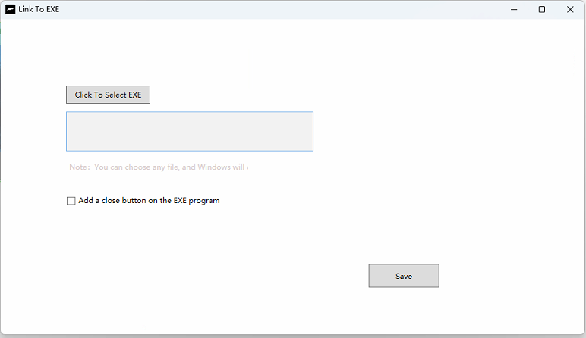

5.8 Mouse click effect
Right-click image-Mouse press effect Designates when the user clicks on the image, the image changes to the press image effect

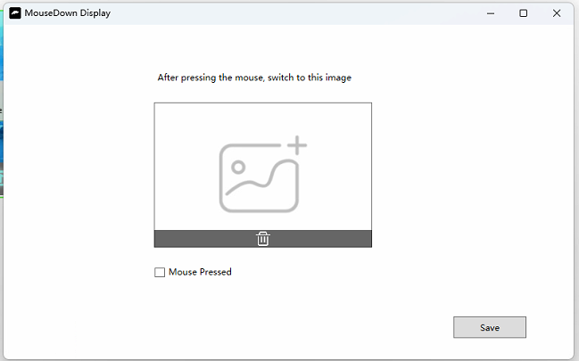
Default mouse press: This is the image that appears when checked

5.9 Replication
Right-click the image-Copy, and then you can paste it to another page
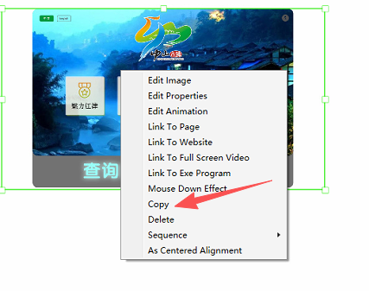

Right-click the blank space on other pages-Paste
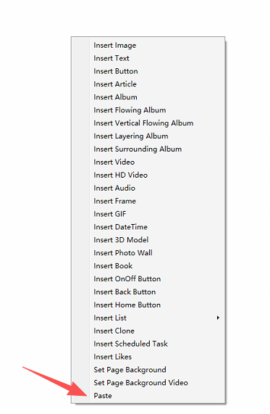

Make full use of the copy function to complete the production quickly

5.10 Erasure

Right-click image-Delete
Delete the current image

5.11 Staircase sequence

Right-click the image – sequence – Send to Back
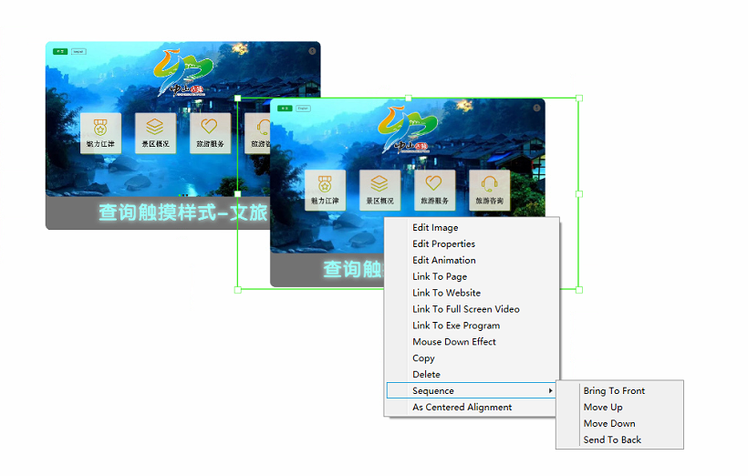
When two images are overlapped, you can set the order of the images.

6. Text

6.1 Inserting text
Right-click-Insert Text

6.2 Editing the text
Enter the text box and type the text directly.
The dot in the lower right corner can stretch the width. Enter in the text and the height will increase automatically.
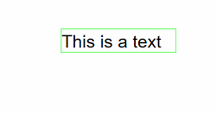

7 Article 7

7.1 Inserting articles

Right-click in the blank space-Insert article
The content of the article can be a Word or Pdf file
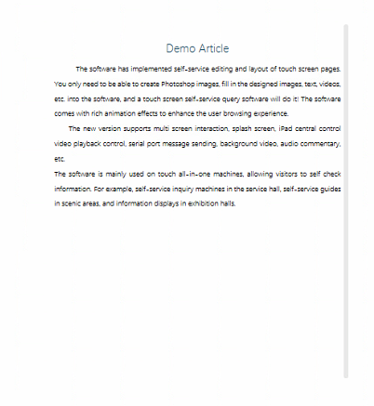

7.2 Editing articles

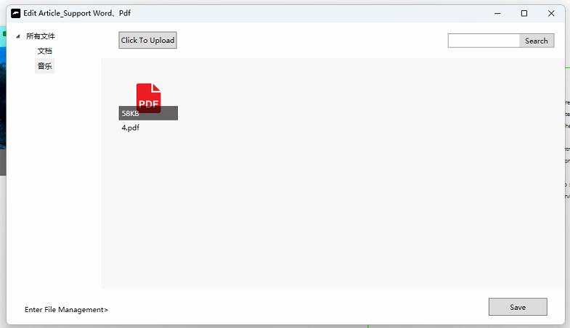
Right-click an article-Edit an article

7.3 Editorial attributes
Right-click article-Edit properties
Check automatic scrolling: Let the content of the article scroll automatically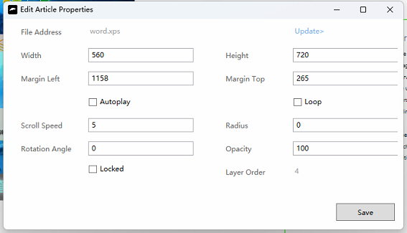

7.4 Article margins
It is recommended to use office word to edit doc and docx files
Layout-Margins-Customize margins, setting the margins and headers and footers to zero
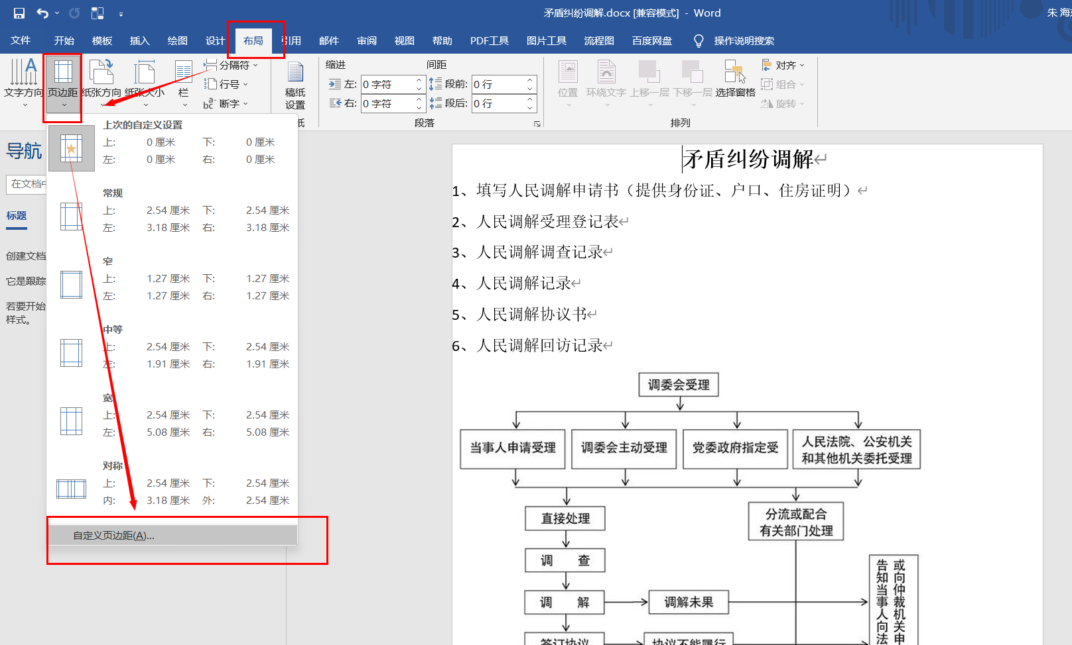

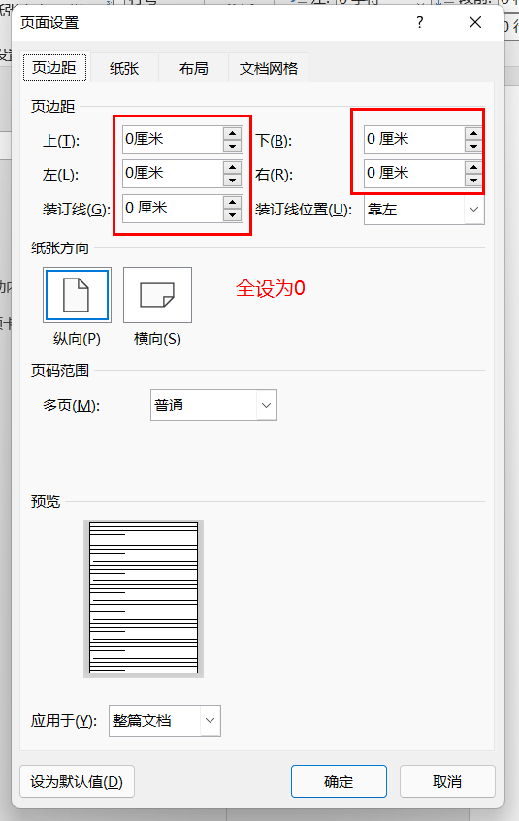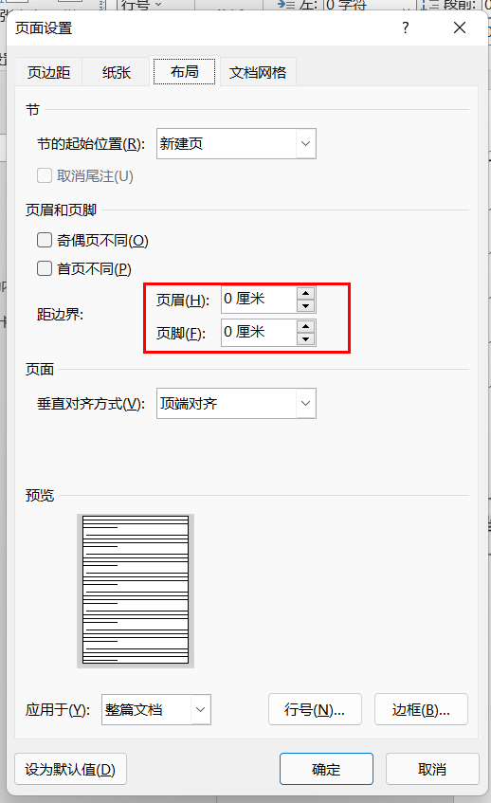

8 8. Photo albums

8.1 Inserting photo albums

Right-click in the blank space-Insert Album
A photo album is a slideshow of images that can be swiped left and right with your finger

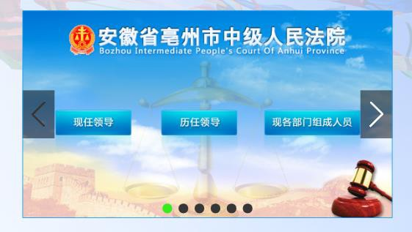

8.2 Editing photo albums

Right-click on the album-Edit album
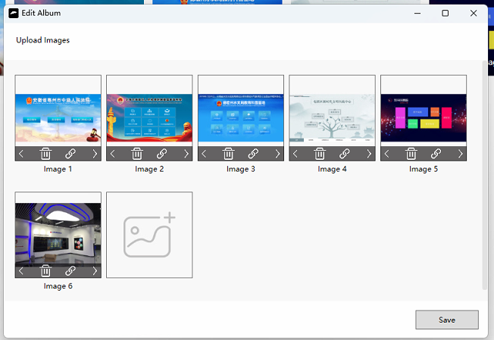

8.3 Editorial attributes

Right-click on the album-Edit properties
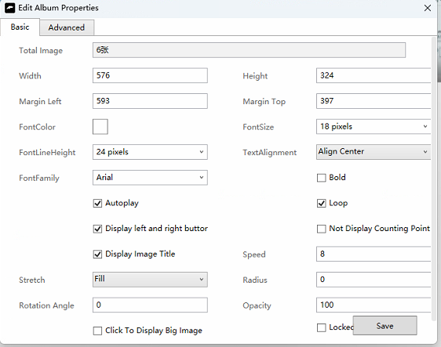

9 9. The Moving Picture Album

9.1 Inserting a flowchart
Right-click the blank area-Insert flow album
Images flowing from right to left are also used for scrolling text announcements
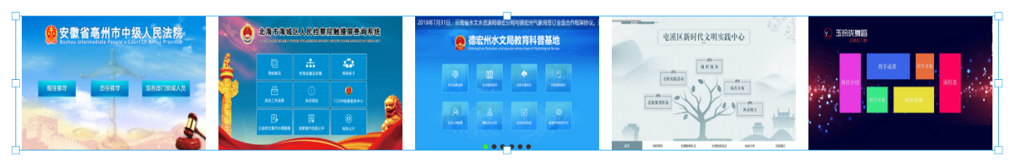

9.2 Editorial attributes

Right-click on the album-Edit properties
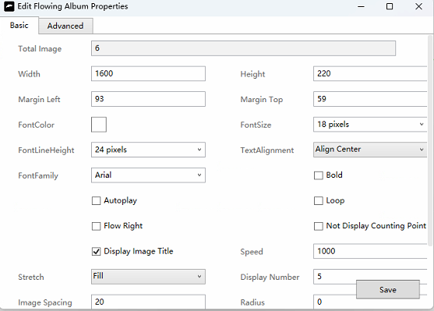

Visible number of images: How many images can be displayed in the current width Image spacing: The distance between two images Automatic switching speed: The higher the number, the faster

10-layer stack photo album

10.1 Insert a layered photo album

Right-click the blank area to insert a layered album. A more three-dimensional image display feature that allows you to set up links for each album and click to view the full image.

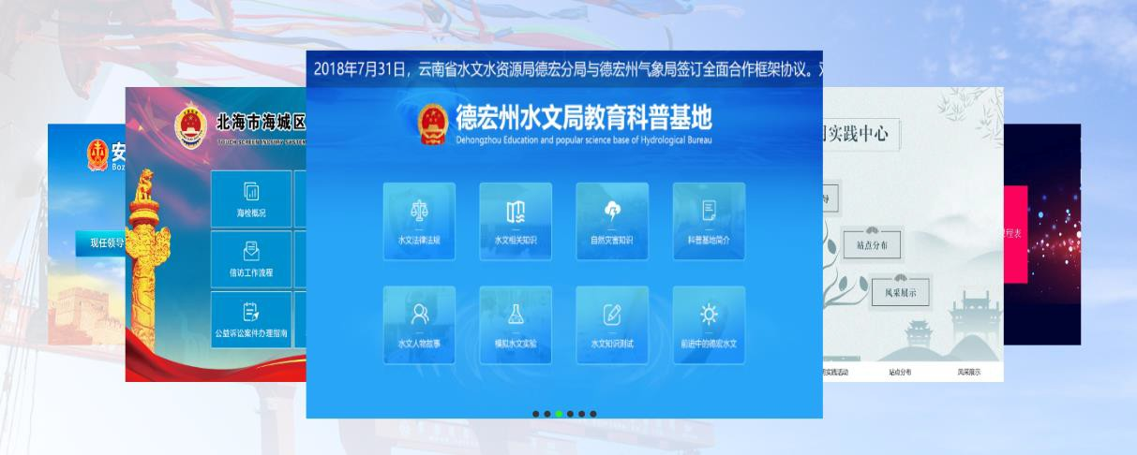

11 11. Video

11.1 Inserting a video

Right-click in the blank space-Insert video
Supports mp4, avi,wmv,mpg,mov video formats

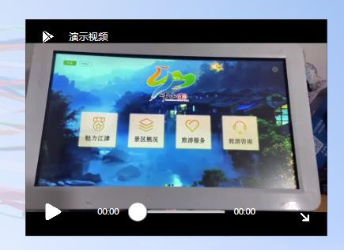

11.2 Edit video

Right-click video-Edit video
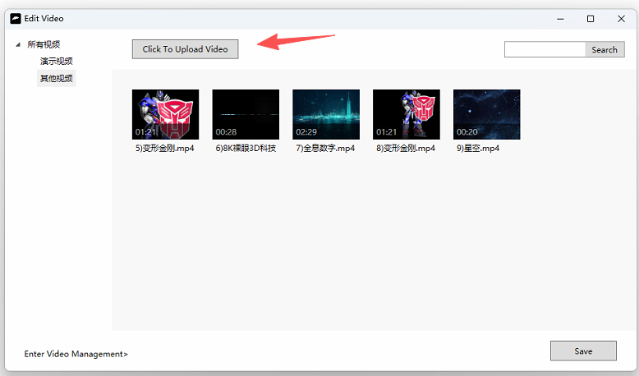

11.3 Editorial attributes
Right-click video-Edit properties
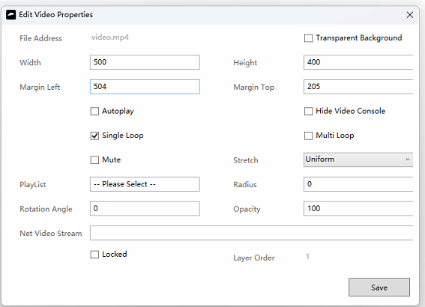
Automatically play the video, check to automatically play the video
Hide the video control panel, check to hide the play/pause button and progress bar
Mute, check to turn off the video
Loop video (single): Select this to loop the current video
Loop videos (multiple songs): Select to loop videos in the playlist
Play list: Plays all videos by default; you can also select a specified folder, so that only the videos in this list are played in rotation
video display ：
By default, it displays normally;
Stretching and filling the video area will distort;
Stretch proportionally, always keep the video in proportion, and the edges will not be visible

12 small window

12.1 Insert small window

Right-click the blank area-Insert small window
A small window is a nested page that displays other pages within it. You can scroll up and down to view the contents
The width of the scroll bar is 10 pixels;
If there is a scroll bar on the right: the width of the small window = page width + scroll bar (10 pixels)

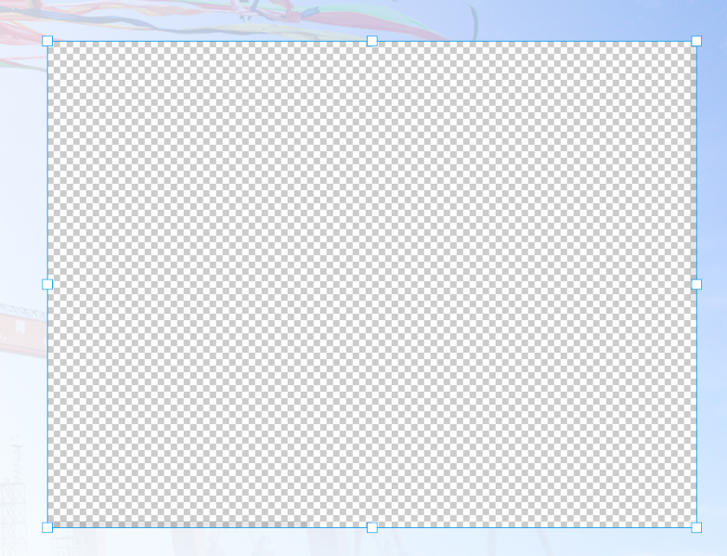

12.2 Edit small window

Right-click the small window-Edit the small window-Select a page to display

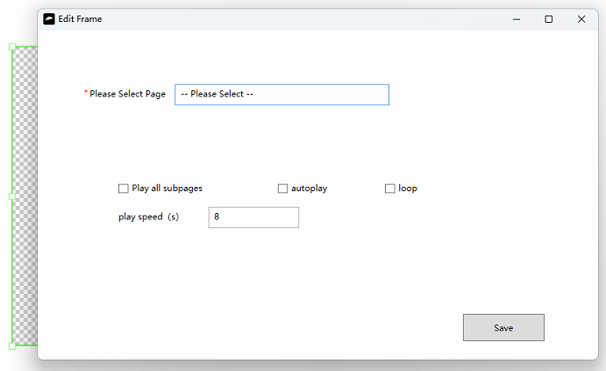

12.3 Selected page width and height

Right-click the selected page-Properties The selected page can specify width and height to fit small window displays

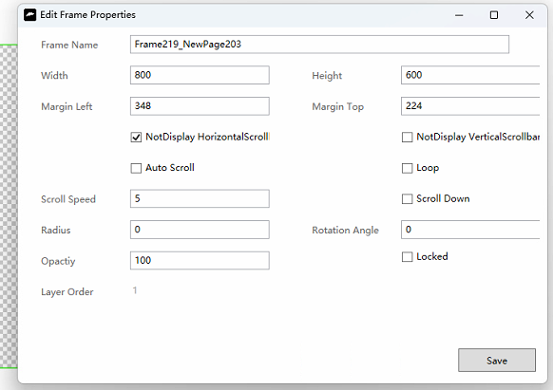

13 Pop-up

13.1 Inserting pop-ups

Right-click image-link to page-check the pop-up
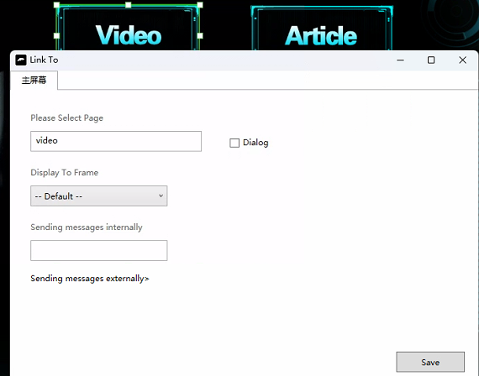

13.2 Width and height of pop-up pages

The width and height of the page should be set to less than the screen resolution for the pop-up page

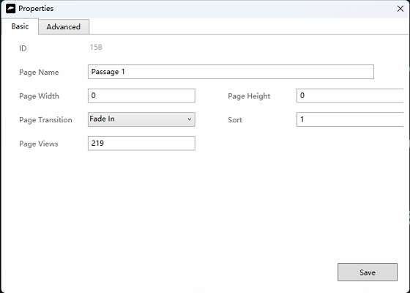
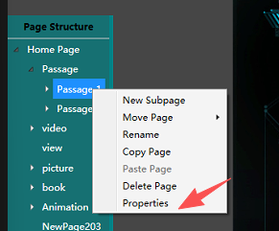

143D model
Model inserted into the page in 3DMax, automatically rotated

14.1 Inserting 3D models
Right-click in the blank space of the page-Insert 3D model
Right-click and drag to change the Angle of the model
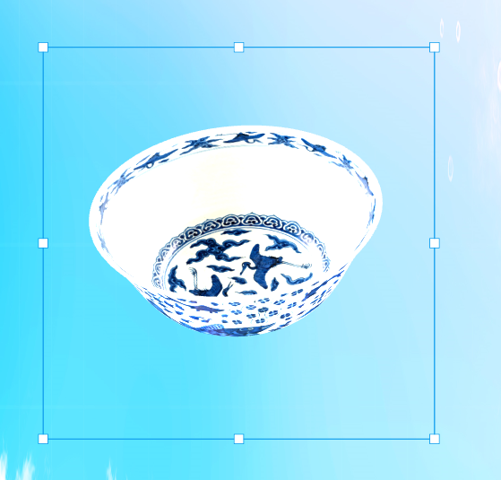

14.2 Edit 3D model
Put all the obj and texture files from 3DMax into a folder, then
Right-click the 3D model-Edit the 3D model-Click Upload, select this folder, and you are done.

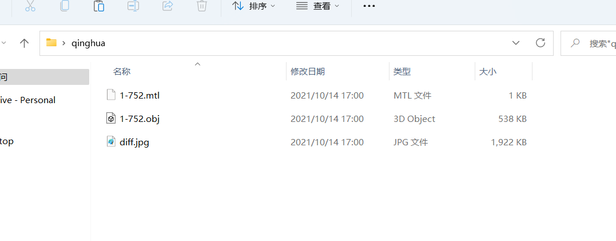

15 GIF images
The software displays GIF moving pictures

15.1 Inserting a GIF
Right-click in the blank space-Insert GIF
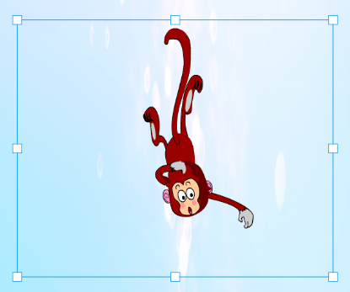

Animation

16.1 Edit animation

Right-click image-Edit animation can be added to images, videos, albums, text, articles and other controls

Animation type: Animated
From left-to-right, from right-to-left, from top-to-bottom zoom in/out From left-to-right, from right-to-left, from top-to-bottom zoom in/out From left-to-right, from right-to-left, from top-to-bottom zoom in/out From left-to-right, from right-to-left, from top-to-bottom zoom in/out From left-to-right, from right-to-left, from top-to-bottom zoom in/out From left-to-right, from right-to-left, from top-to-bottom zoom in/out From left-to-right, from right-to-left, from top-to-bottom zoom in/out From left-to-right, from right-to-left, from top-to-bottom zoom in/out From left-to-right, from right-to-left, from top-to-bottom zoom in/out From left-to-right, from right-to-left, from top-to-bottom zoom in/out From left-to-right, from right-to-left, from top-to-bottom zoom in/out From left-to-right, from right-to-left, from top-to-bottom zoom in/out From left-to-right, from right-to-left, from top-to-bottom zoom in/out From left-to-right,
Open Rotate Zoom in/out

Make full use of the above basic animation, you can make gorgeous dynamic effects.

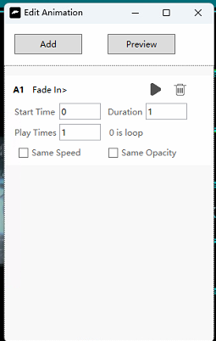
Add animation: Add a basic animation Start time: How many seconds after the page opens to start the animation Duration: How many seconds the animation lasts Number of plays: How many times the animation plays. Set to 0 for loop playback Uniform speed playback: Whether the animation plays at a uniform speed
Constant transparency: Same transparency, by default the image gradually becomes transparent and opaque. You can add multiple animations, preview the overlay animation effect, and delete

17 Back button & Home button

17.1 Insert a return button

Right-click the blank area-Insert Return Button
Click the back button to automatically return to the previous page



17.2 Back to

Right-click the back button to return to the specified page. By default, it returns to the parent page structure.

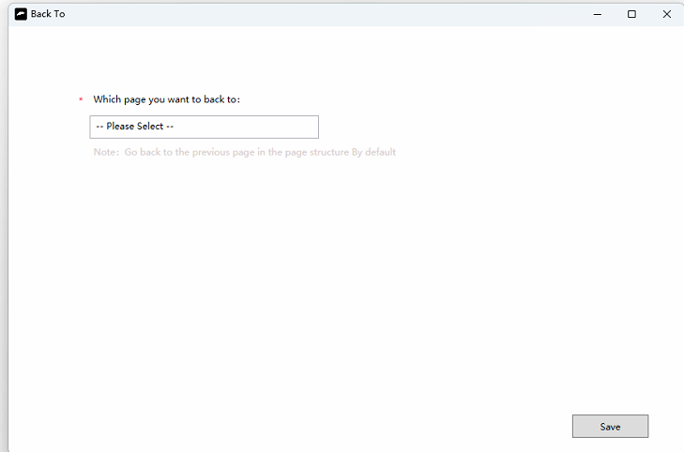

17.3 Insert a home page button

Click the blank area on the right-Insert Home Page button. Click the home page button to return to the home page
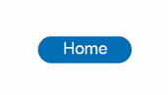

18 HDMI one host multi-screen interaction
A host with multiple screens can be linked to a large screen on the wall using an HDMI cable, enabling the touch screen to control page switching on the wall

18.1 Set up multi-screen communication mode

Setting-Touch screen information-Multi-screen communication mode-HDMI screen extension

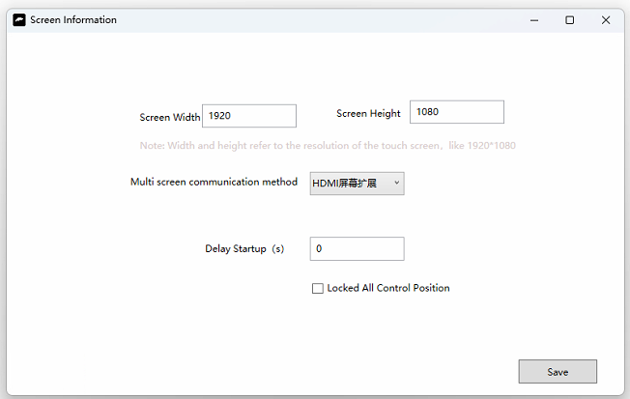

18.2 Screen lists

Setting-Screen List-Add Screen
Home screen: refers to the touch screen
Second screen: A big screen on the wall
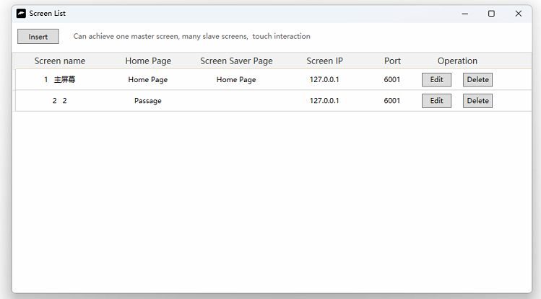

18.3 Add screens

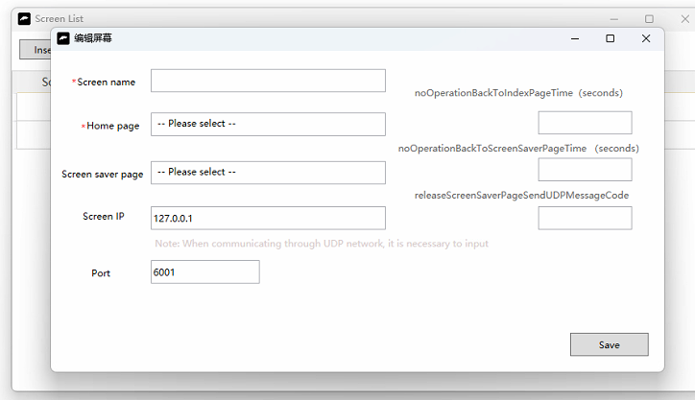
Screen name: Can be customized
Home page: The first page displayed when the software is opened
Unattended automatic return to home page (seconds): How many seconds it takes for the system to automatically return to home page
Screen saver page: The screen saver is displayed when the software enters the screen saver state
Unattended automatic screen saver (seconds): How many seconds without being operated, automatically enter the screen saver page
Screen IP address: The default is 127.0.0.1.
Port number: The default is 6001. Ensure that the host port is open or disable the firewall directly
The screen saver disappears and sends a UDP message: When the screen saver disappears, send a UDP message

18.4 Connect two screens with an HDMI cable

Connect the touch screen to a screen on the wall with an HDMI cable

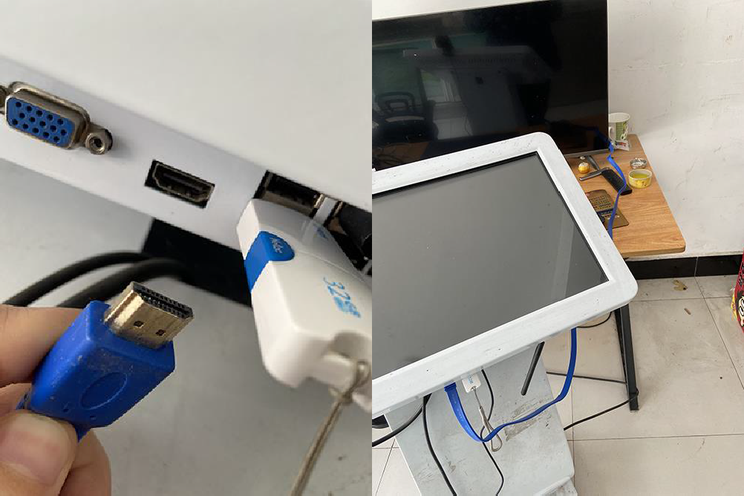

18.5 Set the computer to extended mode
Right-click on your desktop-Show settings-Multiple monitors-Expand these monitors

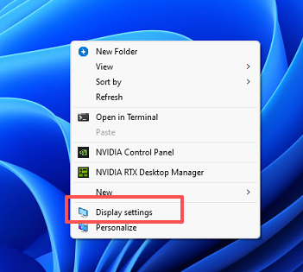
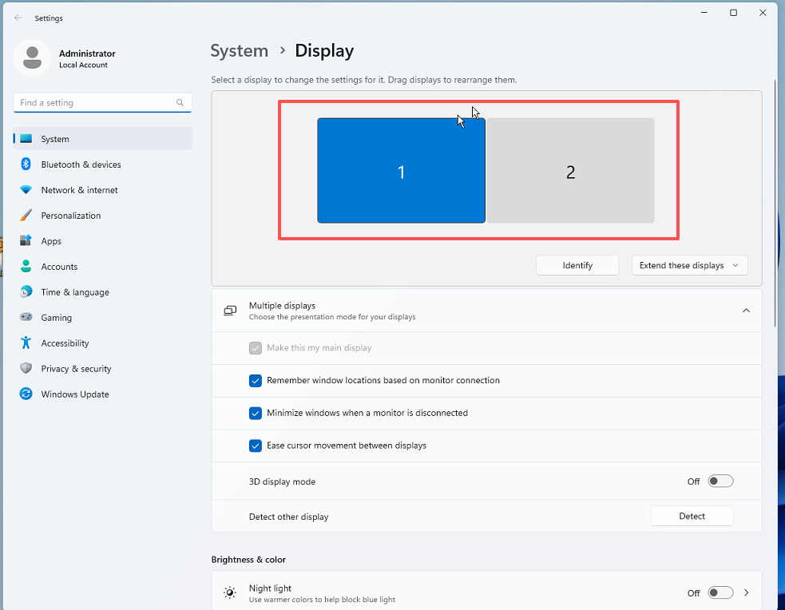

Redraw the display: 1 corresponds to the main screen 2 corresponds to the second screen
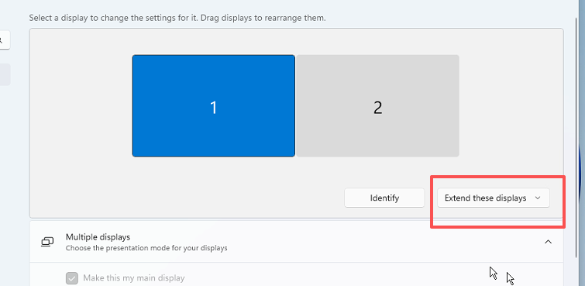

18.6 Designated link

Right-click the image-link

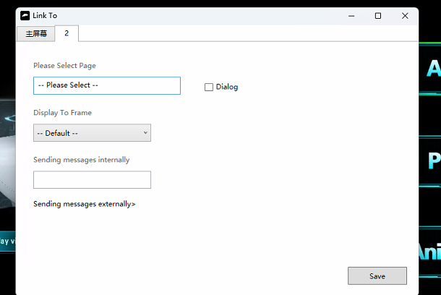
Home screen, no choice
Second screen, select "Video"

When the user clicks on the image on the touch screen, the second screen will jump to the "video" page

18.7 Open the software

Project-Preview At this point, both screens display their respective content

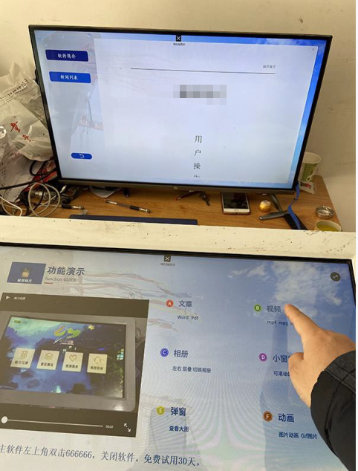

When I click the video button, the TV will switch to the video page

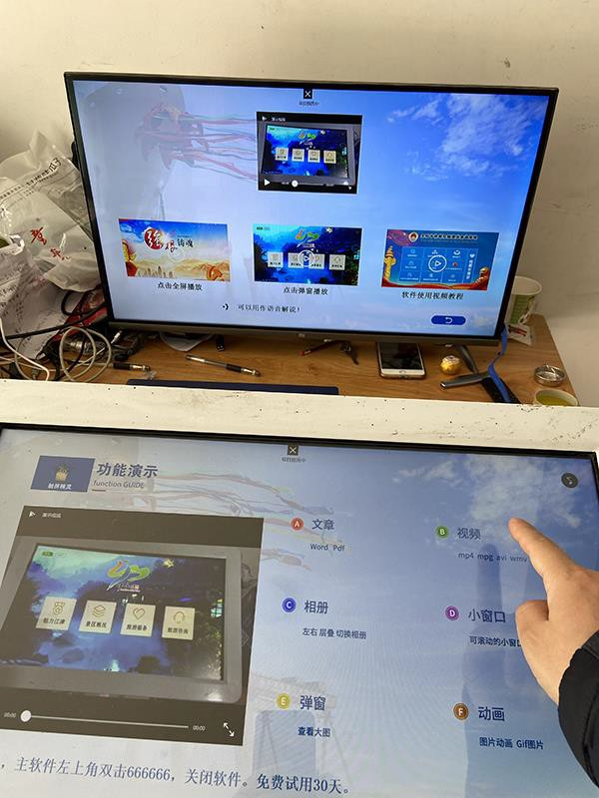

19 UDP multi-host interaction
Main screen: vertical touch screen all-in-one machine
Second screen: The wall screen also has its own console
The vertical touch screen can communicate with the wall screen, and the vertical touch screen can control the wall screen to switch pages.
You need to connect a couple of devices to the same Intranet and communicate through the Intranet IP

19.1 Set up multi-screen communication mode

Setting-Touch screen information
Switch to UDP communication

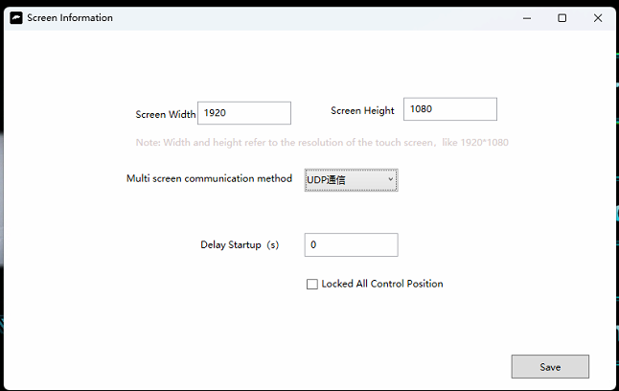

19.2 Screen lists

Setting-Screen list, assign a fixed IP address to each screen
When you arrive at the site, connect the large screen and tablet to the same Intranet and fix the IP address.
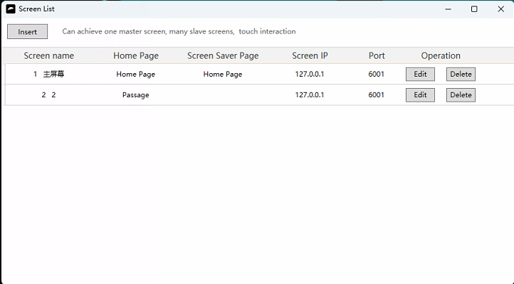

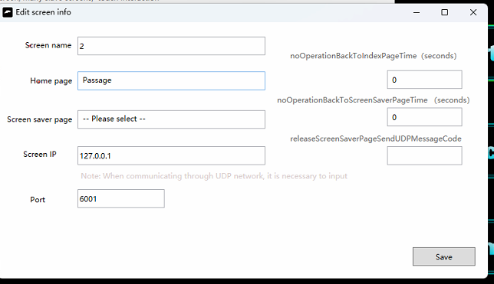
Screen name: Can be customized
Home page: The first page displayed when the software is opened
Unattended automatic return to home page (seconds): How many seconds it takes for the system to automatically return to home page
Screen saver page: The screen saver is displayed when the software enters the screen saver state
Unattended automatic screen saver (seconds): How many seconds without being operated, automatically enter the screen saver page
Screen IP address: Get the internal network IP of each host (see the picture below)
Port number: The default is 6001. Ensure that the host port is open or disable the firewall directly
The screen saver disappears and sends a UDP message: When the screen saver disappears, send a UDP message
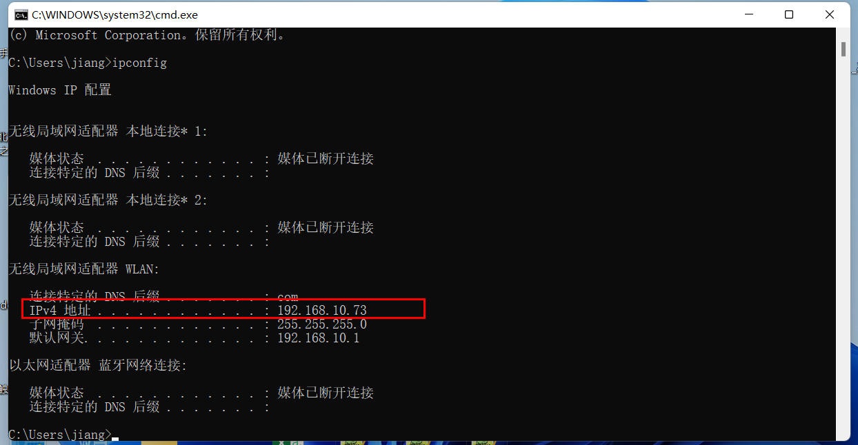
Open cmd, enter ipconfig-get the internal network IP

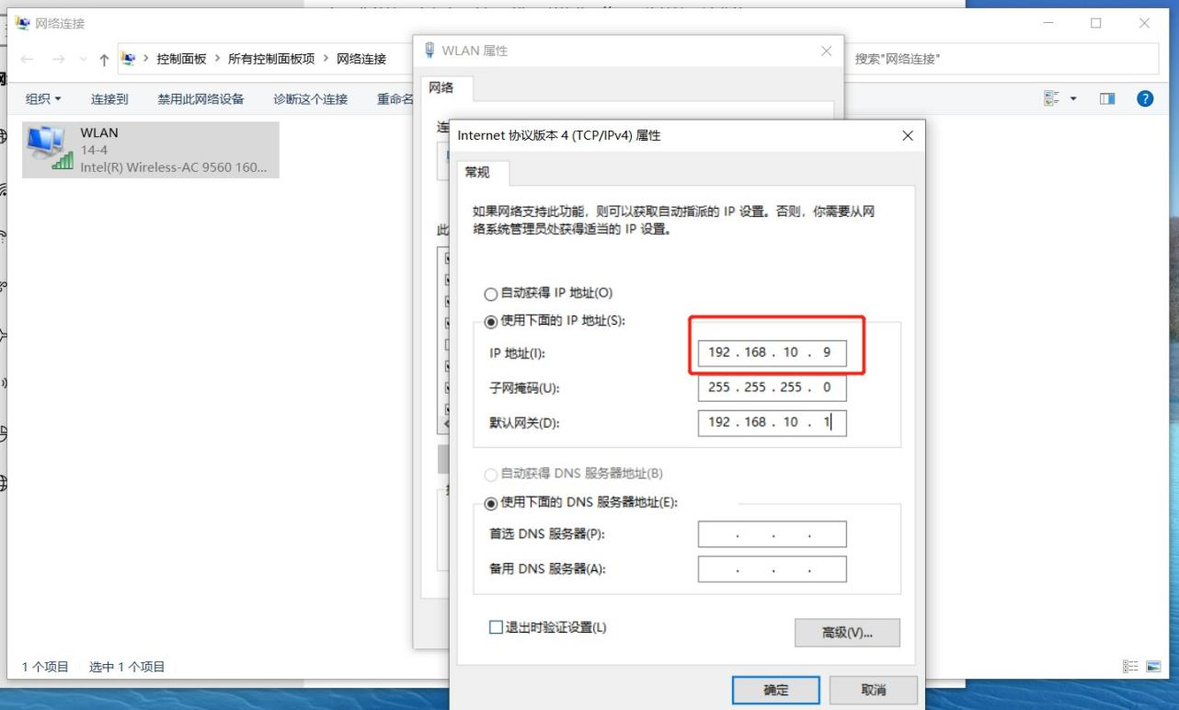

19.3 Designated link

Right-click the image-link
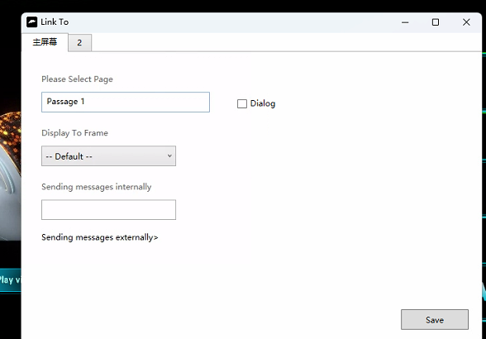
Home screen, no choice
Second screen, select "Video"

When the user clicks on the image on the touch screen, the second screen will jump to the "video" page

19.3 Software is installed on each screen

Windows tablets and wall screens can be installed at the same time to install the query software. Open it and you can test it

20 20 Flying screen
Fly a button from one screen to another and display the corresponding link page
HDMI multi-screen interaction, UDP multi-host interaction, on the above Settings check the fly screen

20.1 Selecting the fly screen

Right-click image → Edit properties → Advanced → Check "Fly screen" → Check "Pop-up fly screen"

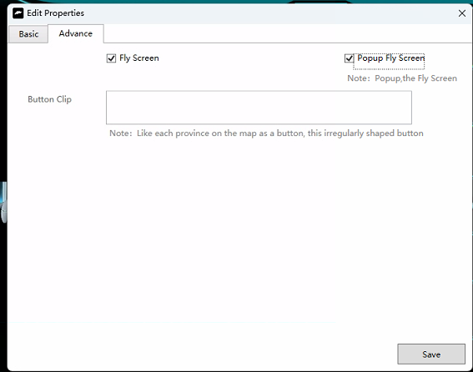

Feiping: Check this box and swipe the image to drop it out
Pop-up screen: When checked, clicking on the image will first pop up a window and then slide out the window

21 Lists and search
Mainly used for news list image list and other scenarios where there are more articles
Here is a list of images:
Realize page display of pictures, pop-up to see large pictures, search according to the name of the page
Current image list = 3 rows by 3 columns, 9 elements
Each element links to a page

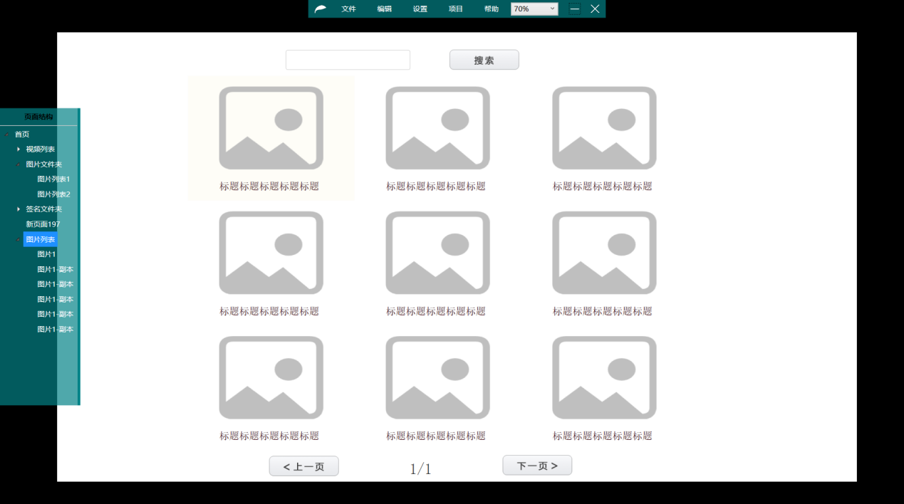

21.1 Insert list templates
Right-click in the blank area-Insert List-Insert List Template
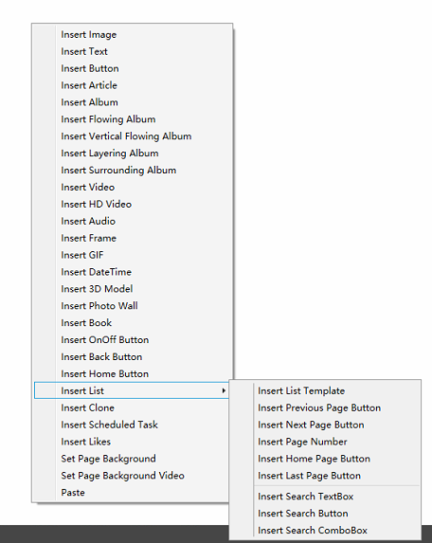

21.2 Edit list templates
Right-click list template-Edit list template
Check to display the page name and display the thumbnail
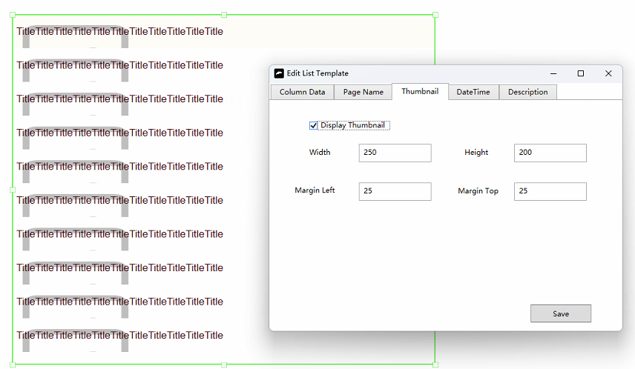

21.3 A column of data
A row and a column in a list, that is, a unit
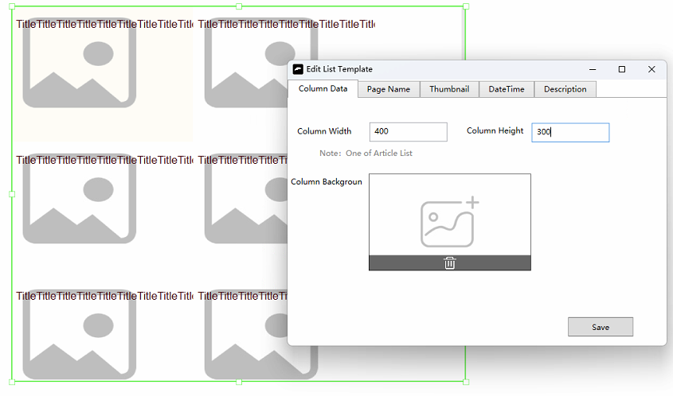

One column of data: There are 9 units in the current list. One column is one unit. Current unit = thumbnail + page name
One column width: the width of a unit
One height column: The height of a unit
A background of a unit: A background of a unit

21.4 Abbreviations
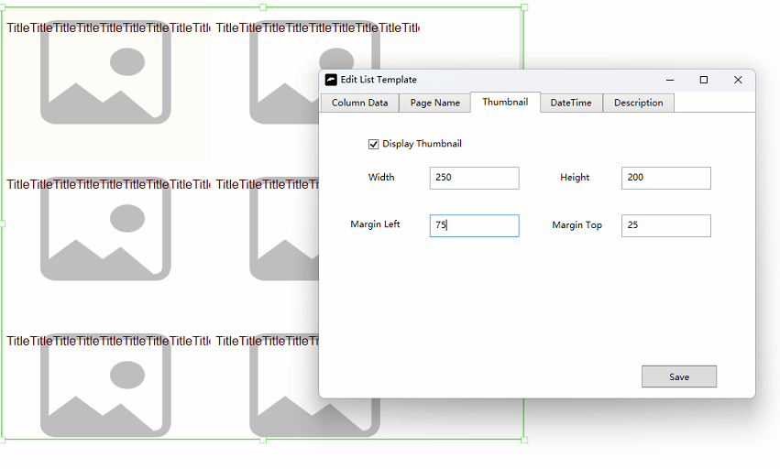
Display thumbnail: Display thumbnail in a unit

21.5 Page name
The page name is the title of the image
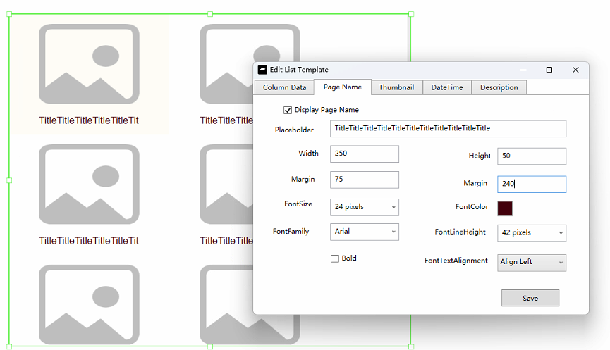

21.6 Editing data sources
Right-click list template-Edit data source
Select "Image List", so that all subpages created under the image list are displayed in this list, with one subpage corresponding to one unit
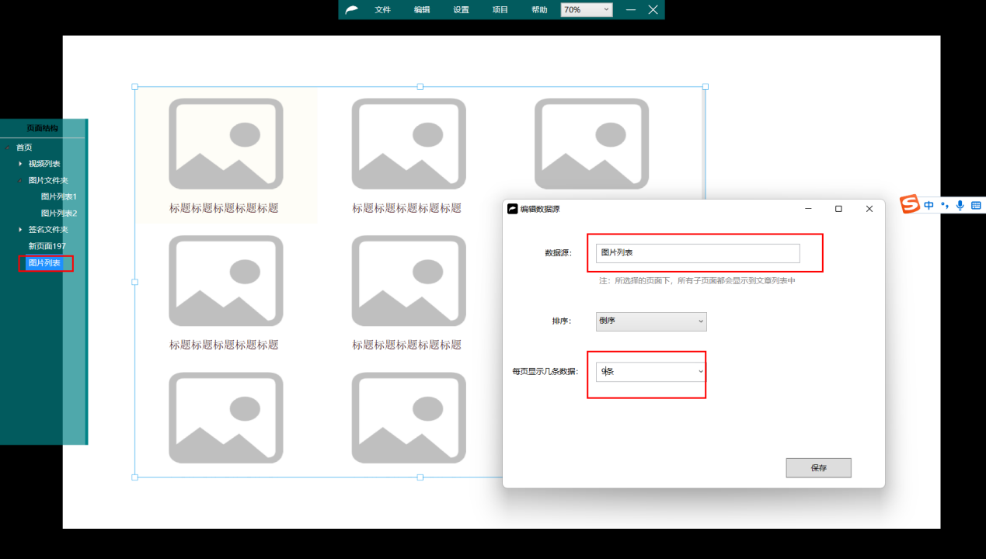

21.7 New pages
Right-click the image list-New subpage
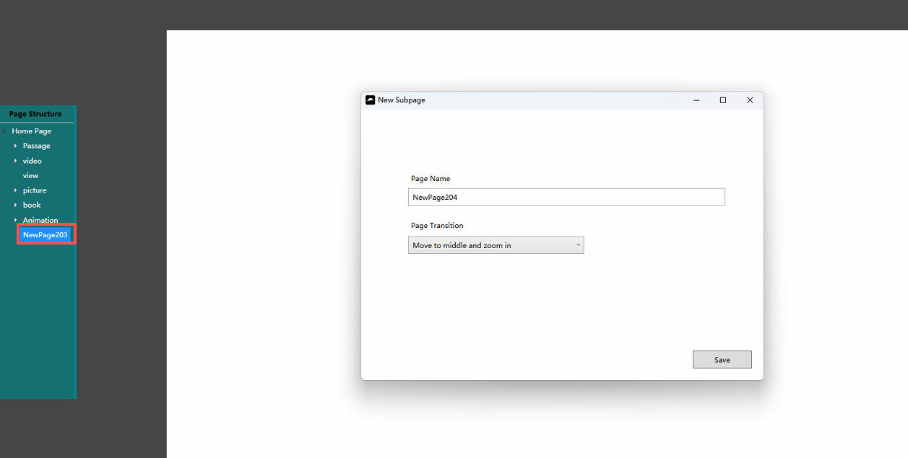

21.8 Modify page width and height
Change the height and width of the page to 1600*900 for use as a pop-up window

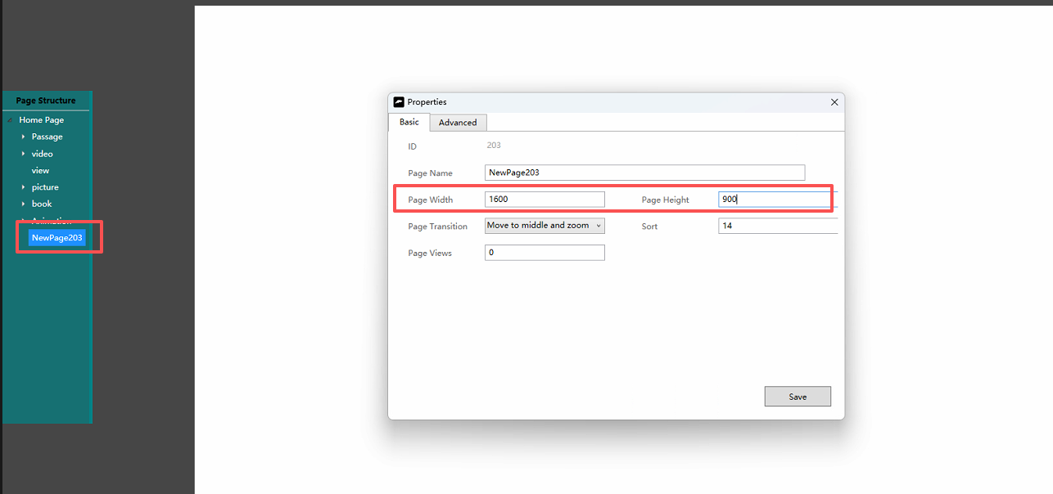

Premium-thumbnail, this is the thumbnail that is displayed in the list
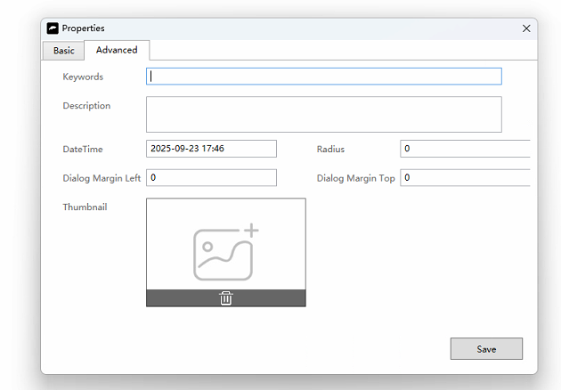
Search keywords: When a user searches, he or she will search for both the page name and the search keyword and the description
Date: The time when the page was created
Views: The number of times the current page has been read
thumbnail: This image is displayed in the image list

21.9 Filling in page content
Right-click in the blank area-Set the background of the page, you can add other content
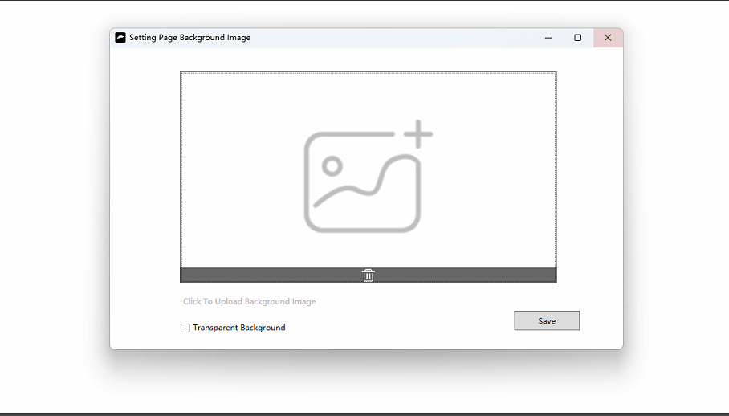

21.10 Copying pages
Copy multiple copies of the "Picture 1" page

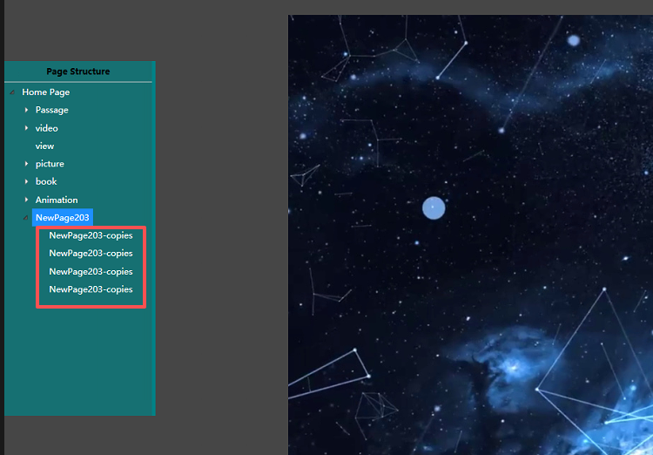

21.11 Links to
Right-click the list template-link to
Select the "image list" and check the pop-up
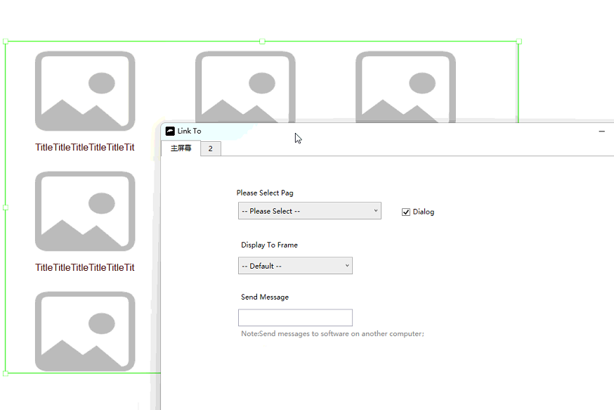

21.12 Project preview
Project-Preview
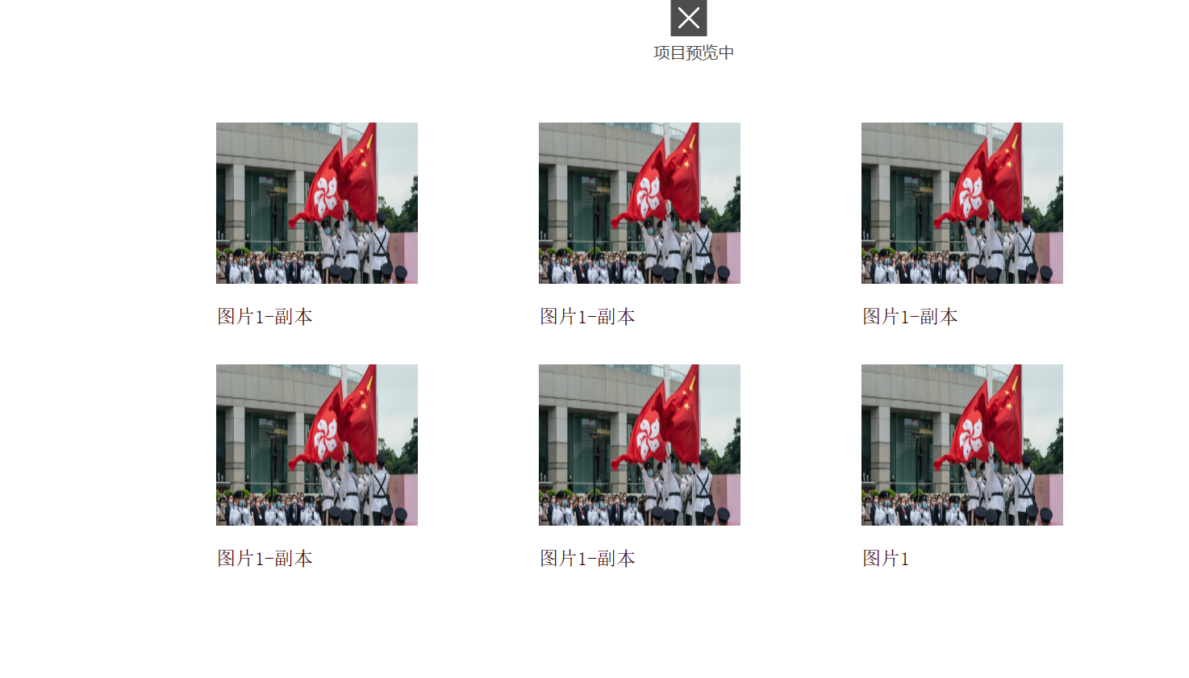

21.13 Search text box
Right-click in the blank area-Insert list-Insert search text box
Right-click in the blank area-Insert list-Insert search button
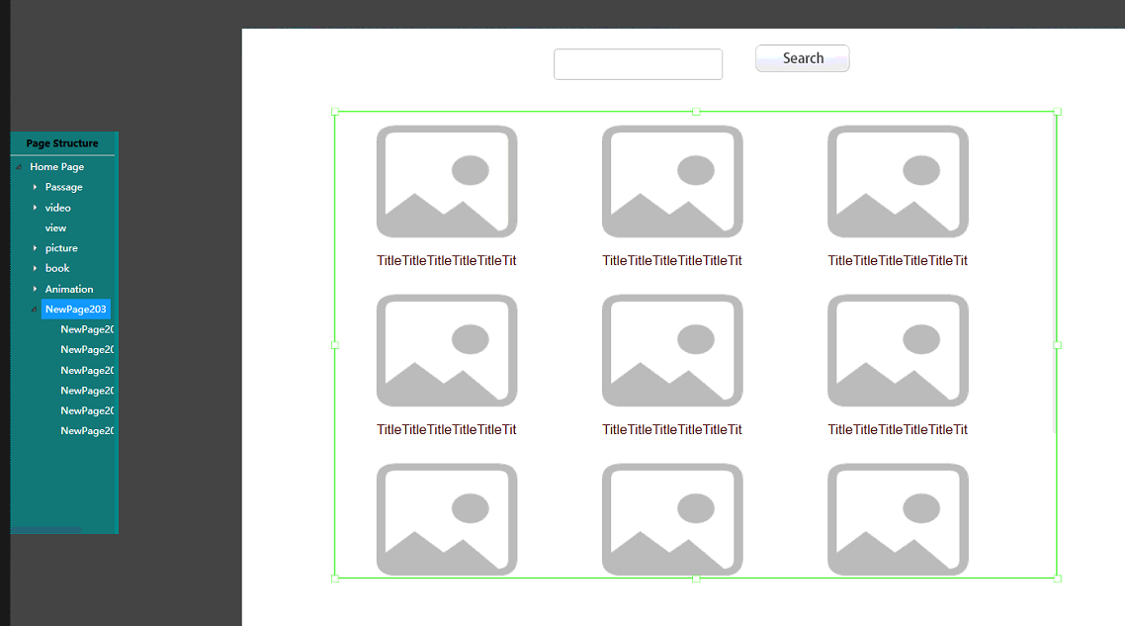

21.14 Search
Project-Preview
Enter the word you want to search for-click the search button
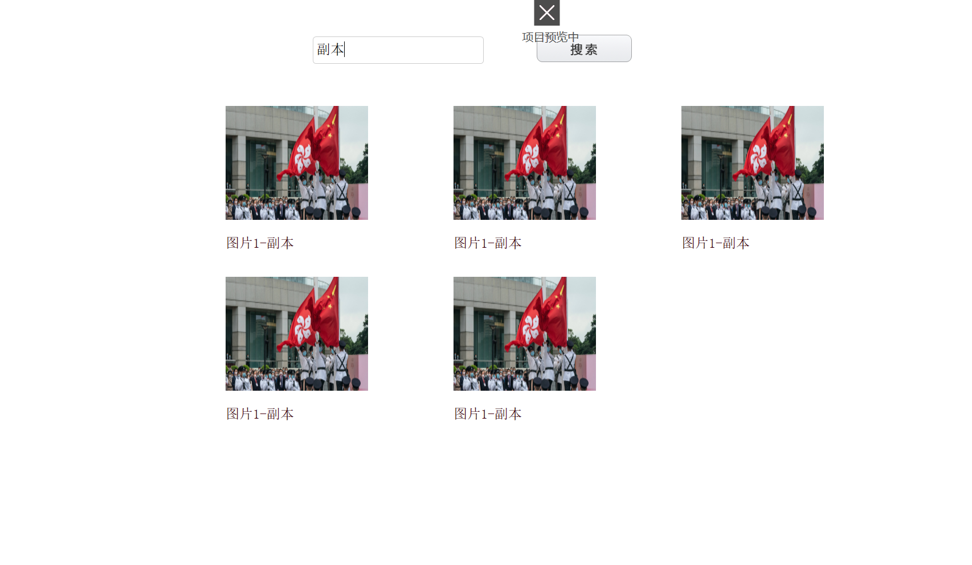

21.15 Page button
Right-click in the blank area-Insert List-Insert previous page
Right-click in the blank area-Insert List-Insert next page
Right-click in the blank area-Insert List-Insert Page Number

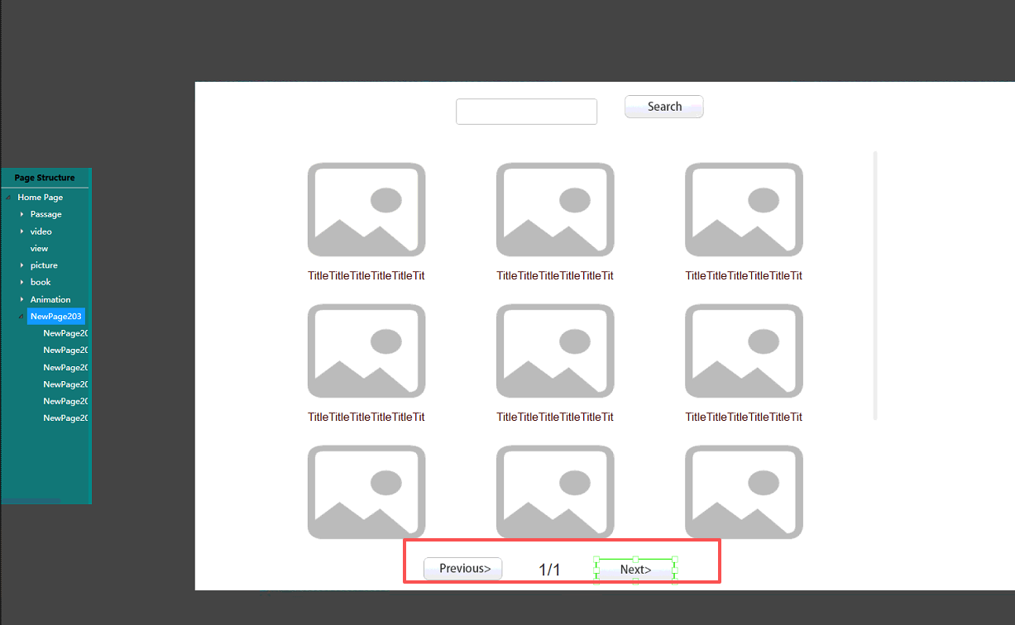

Item 22

22.1 Preview

Preview the current project. Preview is the effect that will be displayed on the touch screen. You can edit the page and preview the effect at the same time, which is very convenient.
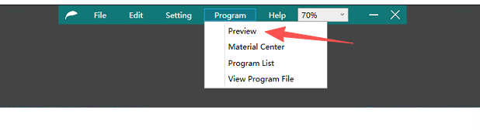

22.2 Material centres
Project-Material Centre
It is the management center of pictures, videos, word, pdf and music files uploaded during editing. You can classify pictures or delete them
You can move and delete files here
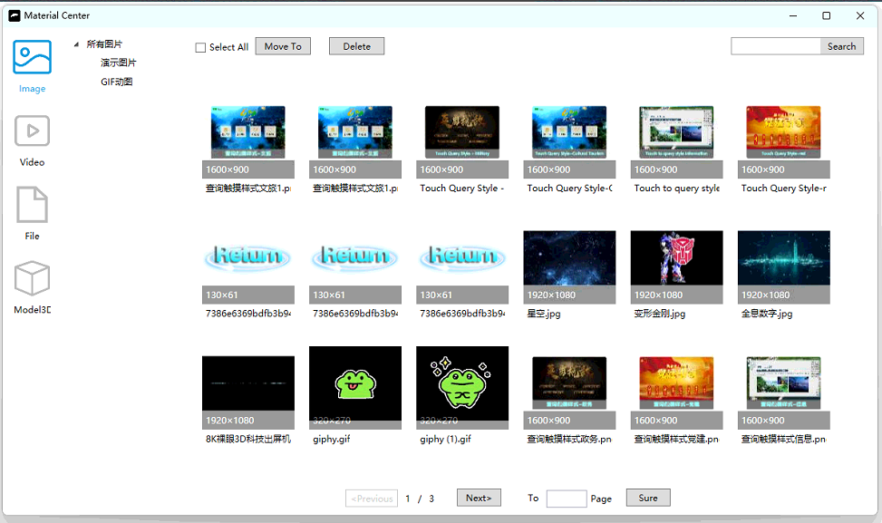

22.3 Transfer of project to touch screen

Step 1: Project-Multi-project management. Look at the name of the project you want to move, click "Project 2", and you will see the "Project 2" folder.

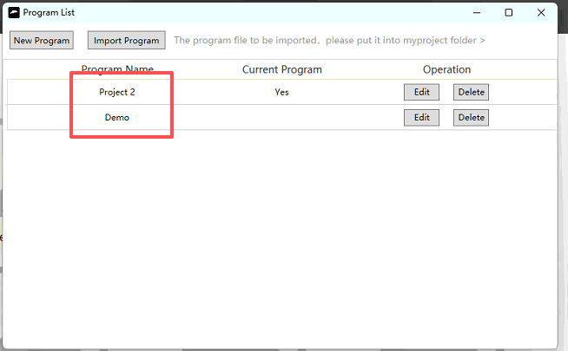
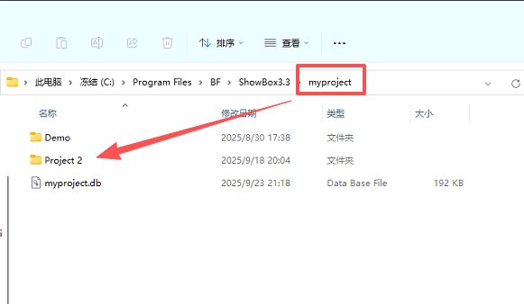
Step 2: Install the software on the touchscreen and open the query software design edition-Project-View project files. Put the "Project 2" folder under myproject

Step 3: Project-Import an existing project by selecting the "Project 2" folder to complete the migration (scroll down and the software will default to locating the "myproject" folder, you just need to go in and find the "Project 2" folder)
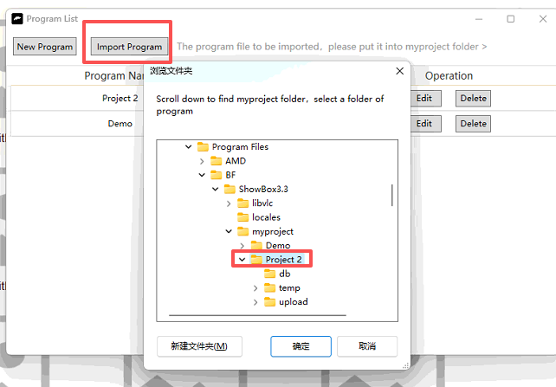

23 23 Help

23.1 Software registration

The software can be tried for 30 days. After you purchase the software, open the query software design version on the touch screen-help-software registration, take a photo and send it to the technician, who will give you the registration code, fill in the code.
After registration, the current touch screen can be used permanently.

24. Software Directive
The software can receive UDP commands
- The central control panel sends UDP commands to the current host
- UDP multi-host interaction, where one host sends a UDP command to another host
- HDMI one host to multiple screens interaction, a screen sends UDP commands to another screen
- Send a serial port message to the host, and then convert it into a recognizable UDP instruction through the Settings-Message conversion

24.1 Instructions that the software can receive
goPage2 links to a specified ID page (right-click on the page name-properties, you can see the page ID)
goToVideo2 plays a video with a specified ID (see the project-Material Management-Video to see the ID of each video)

gotoPreviousVideo ：Previous track
Go to Next Video： Next song
playVideo ：Play video
pauseVideo： Pause video
stopVideo： Stop video
replayVideo： Rewind video
videoForward8 ：Advance 8 seconds
videoBack8： Back 8 seconds
volumePlus ：software volume+
volumeMinus ：software volume-
volumeUp ：Computer volume up
VolumeDown ：Computer volume reduction
noAudio ：computer mute switch
computerShutDown： computer shutdown
softShutDown ：Close software
gotoPageDialog2 ：opens the specified page in a pop-up window. 2 is the page number
closePageDialog1 ：Close the specified pop-up dialog 1 is the page number, if not written, it will close the current pop-up
gotoPreviousImage ：The previous image (album layered album)
gotoNextImage ：Next image (Album Stacked Album)
shutDownExeWeChat ：Close the software WeChat and view the software process name in the Task manager
clickButton2： triggers click button 2 is the button number

At the end of reading, please use the touch screen software!!

